VILLA NOVA NEWS
P.O. Box 32721, Pikesville, Maryland 21282 www.villanovaassoc.org
A Publication of Villa Nova Citizens on Patrol, Inc. (COP) &
Villa Nova Community Association, Inc. (VNCA)
MARCH 2015

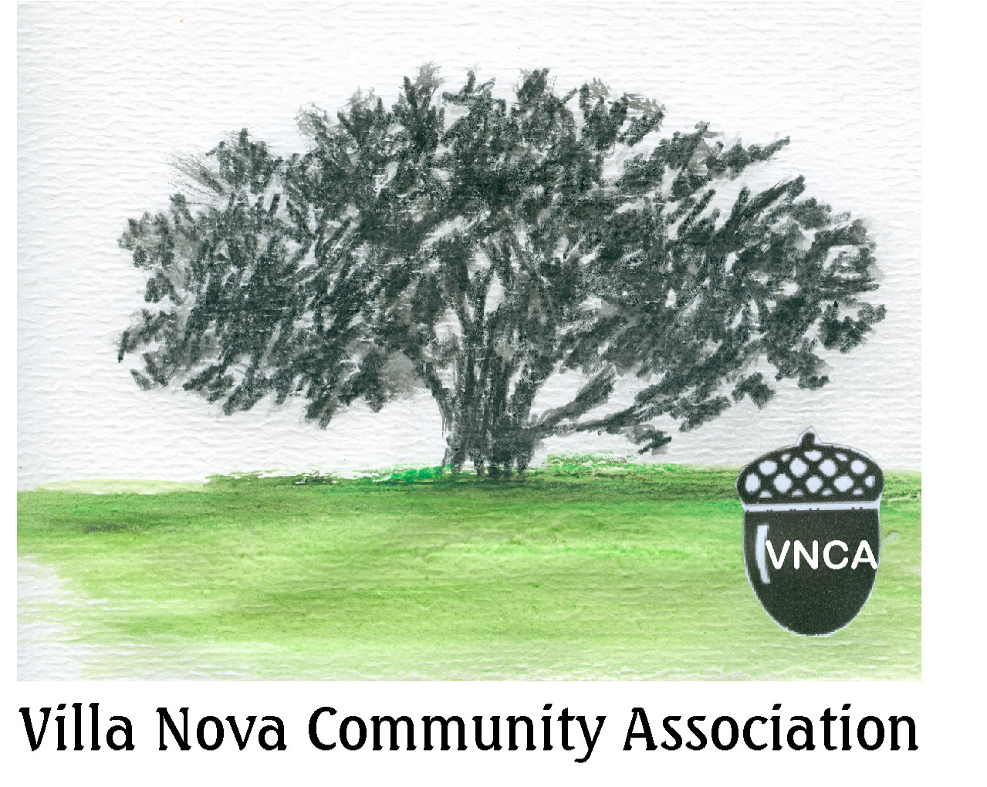

By Mary Dee Smith
VNCA BOARD: President-Fred Ware Newsome; Vice President-Betty Matthews; Treasurer-Sandy Parobeck; Secretary-India Artis

2015 CALENDAR

APRIL 16
VNCA General Meeting - 7:30PM
--------
MAY 16
Spring/stream clean-up
9:00Am - noon
Buckingham RD Bridge
-----------
JUNE 27
VNCA PICNIC
Noon - 4PM
Park @ Prince George & Buckingham RDs

National Night Out - August 4
Flea Market - TBD
November Gen. Meeting - TBD
Dumpster/Shredder Day - TBD
Holiday Decorations - Dec. 19

GENERAL MEETING - APRIL 16th
Please join us the VNCA spring general meeting. Come vote for board officers, hear your elected officials, voice concerns, pay your 2015 dues, volunteer for activities and fellowship with neighbors at the Augsburg Home Town Center, Campfield RD, West Assembly Room @ 7:30PM.
SPRING/STREAM CLEAN-UP - MAY 16th
Did you know the Gwynns Falls stream runs through Villa Nova? Come join us for the annual Spring/Stream Clean-Up. We need help clearing the stream and park of debris, weeding the flower gardens, and planting flowers. Certificates for Service Learning Hours available for students who participate.
2015 VNCA BOARD OFFICER SLATE
President: Fred Newsome - vncapres@villanovaassoc.org
Vice Pres.: Betty Matthews - vncavp@villanovaassoc.org
Secretary: India Artis ▪ Treasurer: Sandy Parobeck
COMMITTEES:
Members: Betty Matthews - vncamembers@villanovaassoc.org
Zoning: Sheila Lewis - vncazone@villanovaassoc.org
COP: Bob Landau - vncop@villanovaassoc.org
Any VNCA member may join the board; join us the 3rd Wednesday of the month, 7:30PM, Augsburg Home Town Center, Campfield RD, Building 11, 2nd floor meeting room.
SPECIAL NOTE. . .
Borrowing from another neighborhood newsletter, Windsor Hills Neighbors, Inc., as it describes its community as a “very special place with very special people," here are some thoughts for 2015 and beyond:
1. Remember, we are community. We might not always agree with one another, but respect and caring always guide us.
2. Each of us must take responsibility for our own homes, property and community. If we retreat into our homes, the neighborhood will slowly but surely fall apart. The message will go out to opportunists and criminals that we don't are. We will not let this happen!
3. Personal responsibility takes many forms in a neighborhood and can be little things: setting your garbage out on the right day and not letting it spread into the street; clearing leaves from the storm drains; picking up trash in the park areas (for decades, our neighbors, the Latanes, have cleared the trash from the Villa Nova Park; keeping your yard mowed; reporting a burned out street light; checking on your neighbors; reporting the abandoned or inoperable vehicle on your street or calling the police if you suspect suspicious activity.
4. Volunteer! Join the Villa Nova Community Association, Inc. as a
dues paying member!

CITIZENS ON PATROL NEWS
KEEP VILLA NOVA SAFE!
COP NEEDS YOU NOW!
Contact: James Branch
443-857-7419/vncop@villanovaassoc.org
VILLA NOVA COP OFFICERS
Director: Bob Landau, 410-458-6937
Asst. Director: James Branch, 443-857-7419
COP CAR SIGNS LOCATION:
7017 Queen Anne RD in the rear (next to the church)
---------
PIKESVILLE POLICE
COMMUNITY RELATIONS COUNCIL
The Pikesville Police Community Relations Council meets the 4th Tuesday of the month at 7pm at the Baltimore Hebrew Congregation on Slade Ave. just past Park Heights Ave. NOTE: In Nov. & Dec., the meetings are held on the 3rd Tuesday because of the holidays.
HOME SECURITY CHECKS
Baltimore County Police offers FREE Home Security Surveys to make your home safer.
Call: 410-887-8775.

DEADWOOD & BROKEN TREE LIMBS
This winter has left us all with a lot of tree junk on our lawns. If you want the County to take it away, bundle it into loads 3 ft. long and place it on the curb on yard pick up day, Wednesdays starting in April.

SPRINGTIME PLANTINGS
It’s time to start getting our yards beautiful for the spring. Start thinking about some native plants to plant and trees to replace any dead or dying trees. Remember, the greenery not only beautifies, it helps with the ecological system and preserves the wildlife we are known for in Villa Nova. We have an oasis of beautiful birds, bluebirds, canaries, finches, hummingbirds, etc. and interesting wildlife here. A list of native plants include:
french marigolds; foxglove; rosemary; mint; crape myrtle; african lily; fountain grass; hens & chicks; dwarf marine heliotrope; heather; yucca; zinnia; brunnera; wisteria; sea holly; tulips; verbena; sweet woodruff; catmint; lamb’s ear; lily of the valley; bee balm; lungwort.

SERVICE CORNER

Please support our neighbors!

Deirdre Elvis-Peterson
Arbonne Independent Consultant ID#18028600
arbonne.com
PURE|SAFE|BENEFICIAL
Ultra-Premium Swiss Skin Care & Wellness
-and-
"Wee! The Children..." Family Childcare
Care for children ages infant to school-age. Before and after care is considered as well with pick up offered at Sudbrook Magnet Middle School & Bedford Elementary School.
Visit my website at www.weethechildren.webs.com for more info.
-and-
Frankferd Farm Organic Buying Group
Join the Frankferd Farm Organic Buying Group: www.frankferd.com. The Villa Nova Buying Group Name is
ELVIS-PETERSON. Order by phone: 724-352-9500; fax: 724-352-9510 or online. Orders placed by Friday are available for pick-up the next Wednesday from the home of Deirdre Peterson
(Bedford RD). Contact Deirdre @ 301-793-6650 or email: TheTempleCS@gmail.com. Frankferd Farms is a family-owned operation in western Pennsylvania that specializes in organic, local, bulk and specialty foods.
-and-
Grass Fed Beef
Order your grass-fed beef from a PA farmer. Contact Deirdre @ 301-793-6650 or email: TheTempleCS@gmail.com
-----------------
Caregiver
Willing to care for an adult female. Offering clients to live in my home. 20 years of experience working with developmentally disabled, mental health and geriatric residents. Reasonable rates and excellent references.
Contact: Darlene of Lancaster RD, 410-484-8746.
-----------------
Tutoring and Avon Sales
Jasmine is your Independent Avon Sales Representative
Math tutoring up to Pre-Calculus
Contact: Jasmine of Essex RD, 410-375-5291 or jazz5s@aol.com
------------------
Landscaping, hauling, light jobs
Contact: Lawrence Greer of Rockridge RD, 443-653-1071
------------------
Cleaning Service
Contact: Keisha Winston of Raleigh RD, 410-340-3112
------------------
To list your service, email: vncamembers@villanovaassoc.org

BALTIMORE COUNTY NEWS
REMINDER. . . NEW WATER METERS
The County is reminding citizens to be wary of solicitations from insurance companies telling homeowners that they are not protected against damage during the installation of the new electronic water meters by the Baltimore County Public Works Dept.
Baltimore County Executive Kevin Kamenetz issued an executive order providing residents with low cost County financing options for the rare occasion where a homeowner might otherwise be responsible for damage. If a pipe breaks due to contractor error, it is the responsibility of the contractor to make that repair, with no cost to the homeowner. If a water or sewer pipe should break during the installation on the homeowner portion of the line (from the water meter to the house) and it is not related to contractor error, the homeowner is responsible for that repair. The homeowner has two options: hire an independent plumber and pay for the repair immediately or the homeowner may allow Baltimore County to pay for the repair and add the cost to the annual property tax bill amortized over 40 years at a five percent interest rate.
The new electronic meters will use a wireless network to transmit water meter usage data directly to the Baltimore City billing system to create more accurate bills. The project will take about three years. http://www.baltimorecountymd.gov/Agencies/publicworks/utilities/automatedmeters.html
------------------------------------
WINTER STORM OPERATION INFO ONLINE
The County website offers the latest on road conditions, current plowing operations, winter storm tips and more using Snowfighter, which also includes Twitter updates from Baltimore County Emergency Management. These updates are also available on Twitter by using our Twitter handle: @bacoemergency.
---------------------------------
TOUR OF BALTIMORE COUNTY
Visit the link below and take a 2 ½ minute tour of Baltimore County - a great place to live, work and raise a family. https://www.youtube.com/watch?v=0_dMDm3YXjo&list=UUIDK1jaFTzM-z_vSFphn4bw
----------------------------------
Keep in Touch with Baltimore County Government:
www.baltimorecountymd.gov
Facebook.com/baltimorecounty; Twitter@BCgov;
“Hello Baltimore County” on Cable Channel 25
CODE ENFORCEMENT
A representative from Baltimore Co. Code Enforcement presented at our November general meeting. Common violations include:
- Grass/weeds over 12 inches
- Trash, junk, debris around property
- Trash cans without lids
- Junkyard conditions
- Unlicensed or inoperable vehicles
- Recreational vehicles - improperly parked, unlicensed, too many
- Non-permitted signs
- Exterior repairs
Report violations: 410.877.3351; online: www.baltimorecountymd.gov; email: paienforce@baltimorecountymd.gov or vncazone@villanovaassoc.org

BUILDING PERMIT INFORMATION
Building Permits are required for the following:
- Accessory structures (sheds, garages, gazebos, etc.) over 120 square feet
- All accessory structures located in Flood Zone A or located in historic districts
- Garages and carports attached to single family dwellings
- Above ground swimming pools over 250 square feet with water depth of 24 inches or more
- All in-ground pools: a 48 inch safety barrier with self-latching; self-closing gates is required
- Retaining walls over 36 inches: engineered drawings are required for over 48 inches
- Fences over 42 inches in height

FENCE REQUIREMENTS
- On a corner lot, no fence or other obstruction to vision is permitted higher than three feet within 25 feet of the corner of the two streets, 15 feet of a street and alley and 10 feet of two alleys.
- A residential fence in a side or rear yard which adjoins a residential front yard, cannot exceed 42 inches if it is setback 0 to 10 feet, 48 inches if setback is 10 to 20 feet, 60 inches if setback is 20 to 30 feet, and if setback is over 30 feet, there is no height limit. Required pool fences and houses more than 200 feet apart are exceptions.
- Fences enclosing in-ground pools must be 48 inches high with a self-closing, self-latching gate.
- Decks greater than 16 inches above the lowest grade and exceeds 120 square feet
- Wood stoves, pellet stoves, and fireplaces
- Additions and structural modifications to existing dwellings
- Enclosing of open porches and decks
- Basement excavations
  - To build a clubroom in an unfinished basement, a permit is not required, provided no structural changes are made to the foundation walls and supports. However, plumbing and electrical permits are required for plumbing or electrical work.
  - If a bedroom is added in a basement, a permit is required and it must have an approved egress window or door to the exterior.
- Change of use of structure
- Razing permits
- Grading over 5,000 square feet
- Alterations to historic houses

Send NEWS for the VNCA NEWSLETTER to: vncamembers@villanovaassoc.org and find the newsletter online at: www.villanovaassoc.org
+++++++++++++++++++++++++++++++

LIBERTY ROAD COMMUNITY COUNCIL (LRCC)
The LRCC represents the interests of community associations and citizens along the western Liberty Road corridor and meets the 2nd Tuesday of the month at 7:30PM at the Randallstown Recreation Center. All are welcome.

DO YOU HAVE A COMPLAINT ABOUT A LIBERTY ROAD BUSINESS?
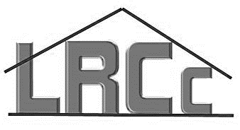 The LIBERTY ROAD COMMUNITY COUNCIL is an organization representing the interests of community associations and citizens residing along the western Liberty Road corridor. LRCC cannot do its job unless we speak up. Please complete this forma and mail it or place it in the mailbox of Betty Matthews, 4106 Villa Nova Rd, Pikesville, MD 21207. Betty represents Villa Nova at the monthly meetings but all are welcome to attend.

As a resident and customer in the area, I am asking you to take pride in your business and clean it up. If you want me to continue to shop here, you will show me you care about this community and your customers.

MY COMMUNITY IS: VILLA NOVA

The LIBERTY ROAD COMMUNITY COUNCIL and VILLA NOVA COMMUNITY ASSOCIATION ask the LIBERTY ROAD BUSINESS ASSOCIATION to present this form to the business listed below and work with the business to improve relations with their customers, the appearance of their business and their community.

NAME OF BUSINESS:_______________________________________
_________________________________________________________
_________________________________________________________
COMPLAINT:______________________________________________
_________________________________________________________
_________________________________________________________
_________________________________________________________

GIVE US OUR DUE!
It’s 2015 and VNCA dues are due for 2015. Help us continue the great work of this association by paying your dues. Dues paying members may vote; attend the annual picnic for free; free table at the flea market; and have access to the Shredder on Dumpster Day. The accomplishments of the VNCA over the past years: Buckingham RD Bridge repaired and reopened; installation of flag pole and war memorial; speed humps on Buckingham RD; 4-way STOP sign at Buckingham and Rockridge RDs; tree planting along stream banks to prevent erosion and protect stream environment; installation of wood duck houses to encourage repopulation; block captain team created; shredder added to Dumpster Day; USPS change to Pikesville, Maryland; repair of war memorial monument and new Villa Nova Welcome sign at the Buckingham RD Bridge. Thank you Villa Nova! All accomplished because of you!
Current VNCA Dues Paying Members:
Artis, India | Villa Nova
Calvarese, Lynn | Lancaster
Dixon, Armeta | Prince George
Dobbs, James | Rockridge
Gibson, Wavie and Sonya | Essex
Jackson, Thomas & Alma | Essex
Jenkins, Joe | Lancaster
Lewis, Robert & Sheila | Buckingham
Matthews, Betty | Villa Nova
Sanders, Christie/Steese, Robert | Campfield PL
2015 VNCA DUES ARE DUE!
I WANT TO PAY MY DUES
Thank you to Villa Nova residents who have paid their 2015 dues. Dues help cover the administrative cost and materials to present the concerns and interests of the community to the county, state and federal agencies. Dues also supply materials for the maintenance of the community gardens and bulletin boards. Living in Villa Nova makes you a member of the VNCA but paying your dues to the association makes you a supporter of the programs and projects and gives you voting rights. If you have not paid, please send your $15 annual dues to:
VNCA, P.O. Box 32721, Pikesville, MD 21282.

NAME________________________________________

ADDRESS_____________________________________

PHONE_______________________________________

EMAIL________________________________________
(Your information will only be used by the VNCA)

I want to volunteer to help:
□ Join Board □ Picnic
□ Spring/Stream Clean-Up □ Flea Market
□ Dumpster/Shredder Day □ Distribute Newsletter
□ COP Patroller □ Become Block Captain

